Analyse packet capture with Wireshark

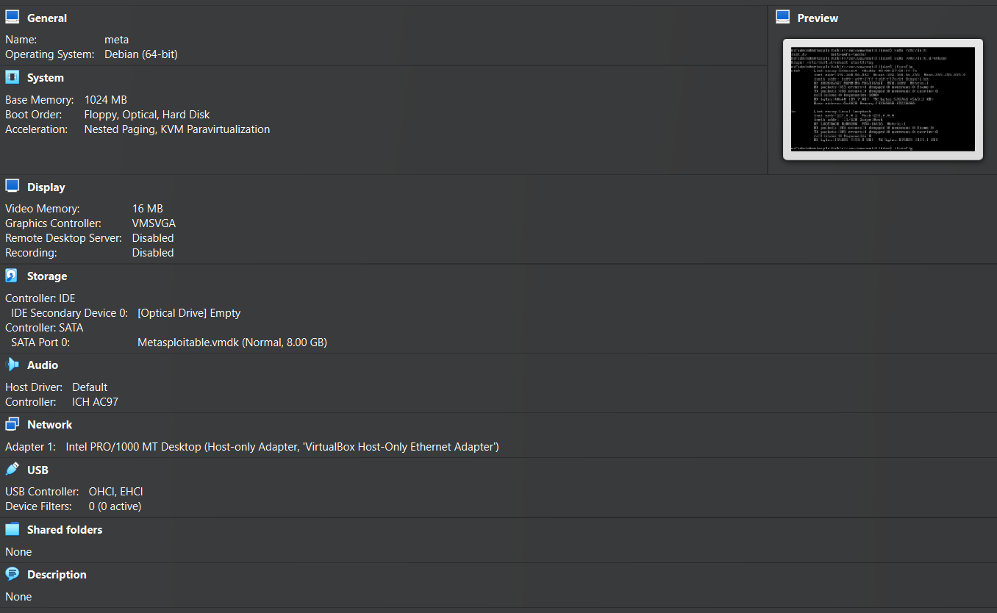

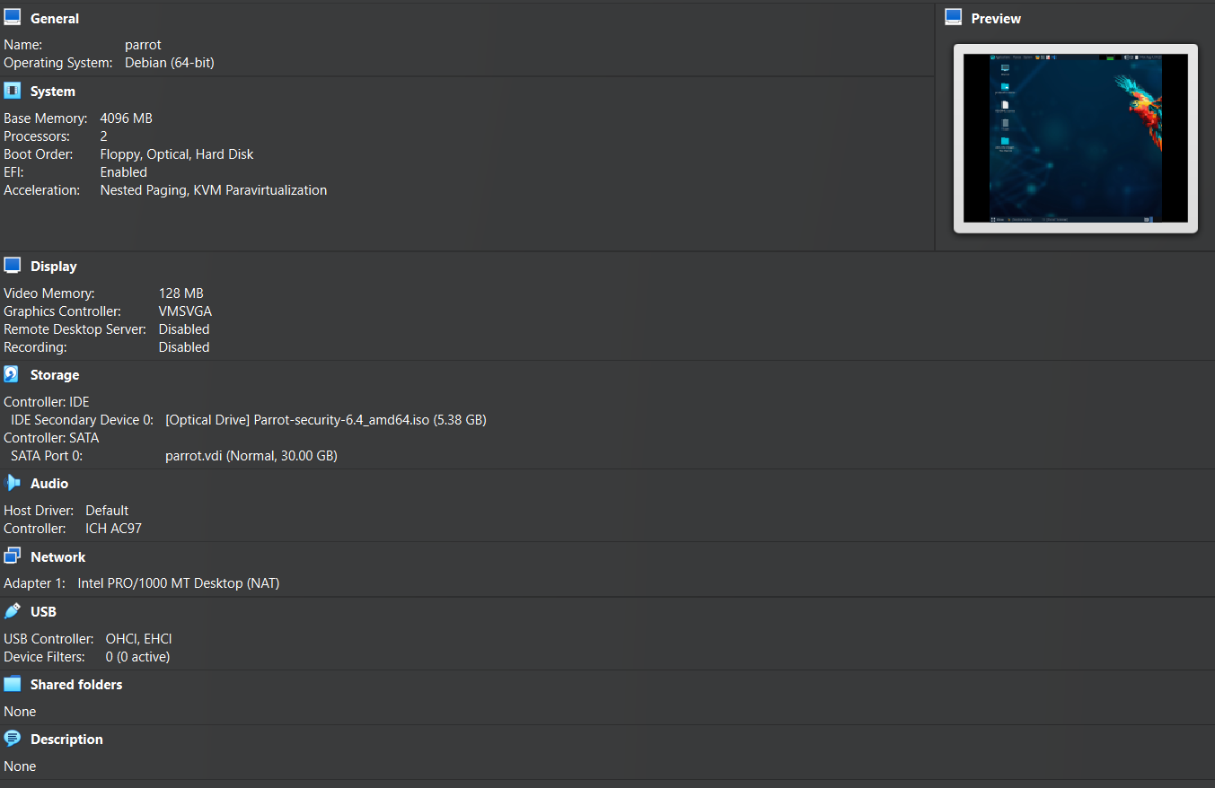

Launch Wireshark.

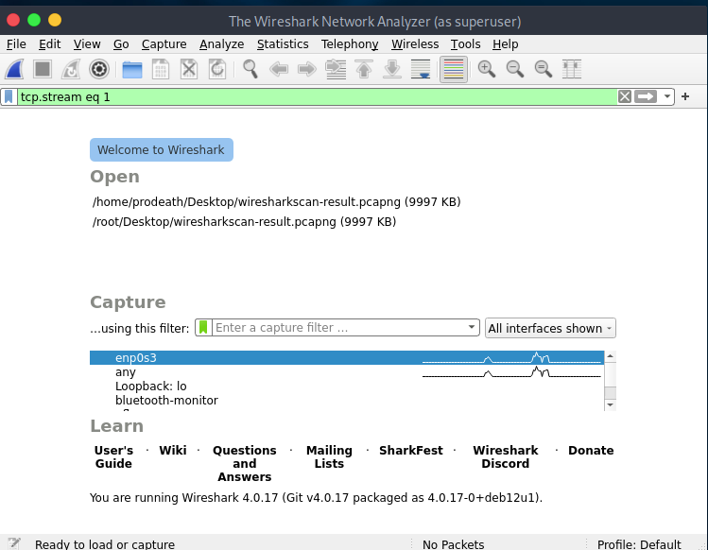

Load the .pcap

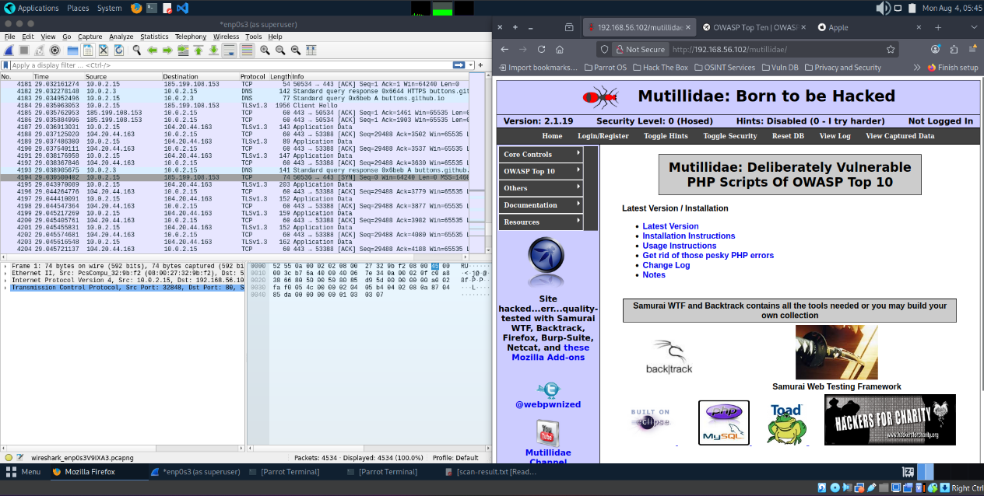

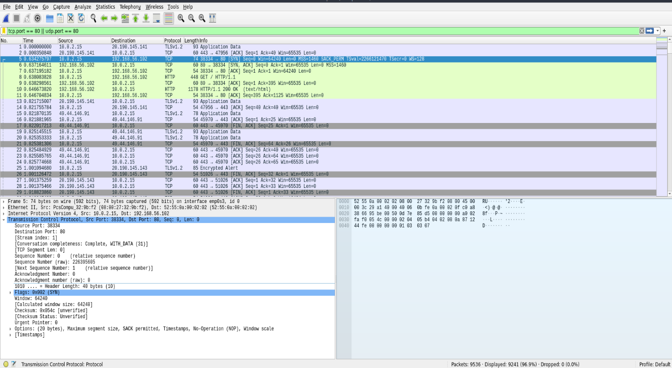

**Apply Display Filter for Ports**

To focus on traffic involving specific ports: tcp.port == 80 || udp.port == 53

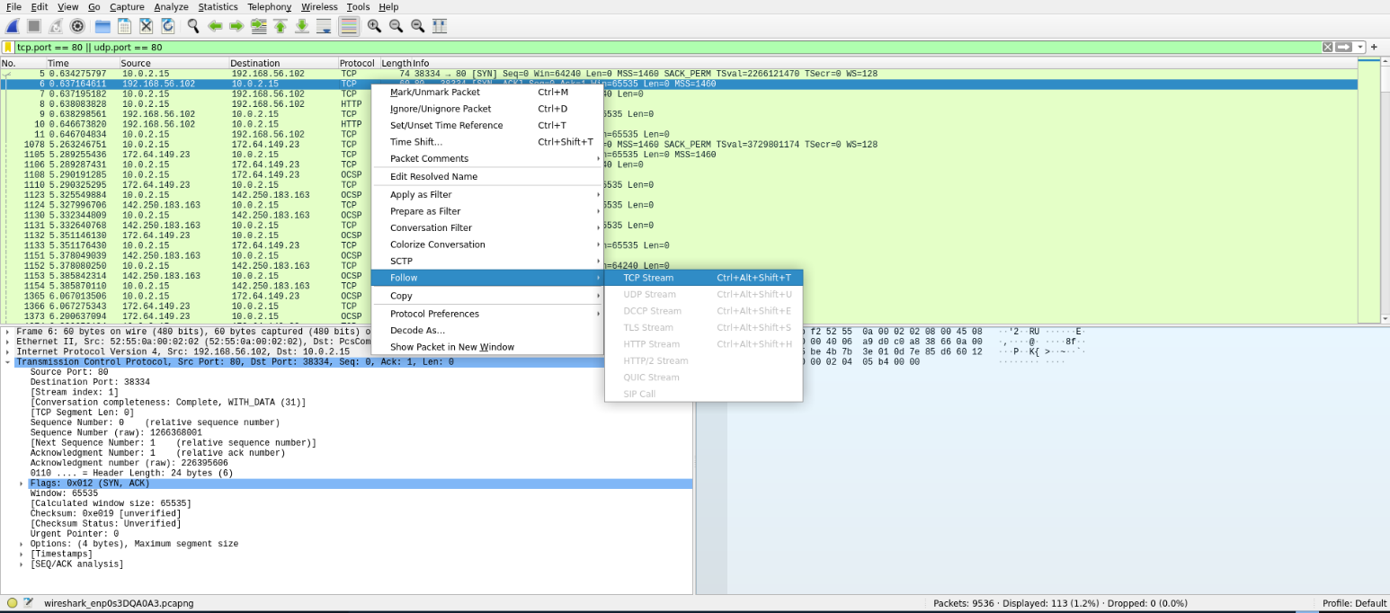

Click on packets using interesting portsand expand the **"Transmission Control Protocol"** or **"User Datagram Protocol"** section. Look for:

**Port number**

**Right-click > "Follow TCP/UDP Stream"**

This is helpful to:

* Reconstruct sessions.
* View protocol behavior.
* Identify services based on data patterns.

